

Ndirine kim Lufhugu

LAB 1 Assignment,MySQL



February 24, 2020

4. Perform the following queries on the **BidvestBank** database and show the screenshot of each query.

1. Find all customer accounts whose balance is smaller than **R700.**

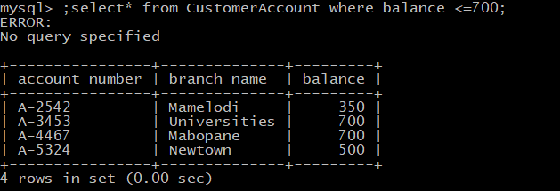

1. Find all name of customers whose city is in **Johannesburg.**

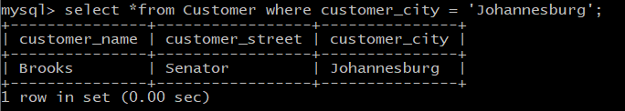

iii) Find all employees whose salary is greater than **R1500** and working branch is not

**Newtown.**

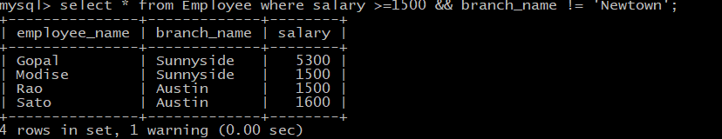

iv) Calculate the average salary of all employees and show the average salary as

**“avg_salary”**

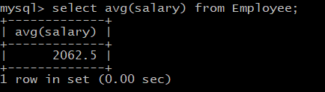

v) Display the bank with the largest number of **Assets**.

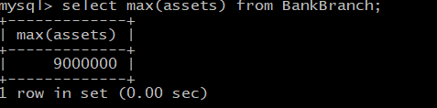

[20 Marks]

5. Provide the **SQL code** which can utilize **BidvestBank** database to provide the following:

1. Display the names of all employees who work in **Sunnyside** branch.

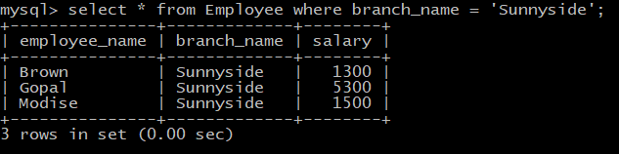

1. Display the **borrower** table.

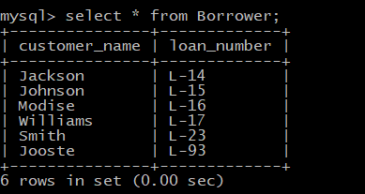

iii) Find the account number for all accounts where the balance is greater than

**R900.**

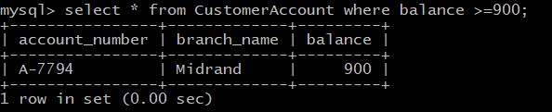

1. Find the account number and balance for all accounts from **Newtown** where the balance is greater than **R600**.

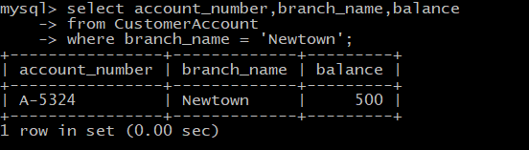

1. Display the branch name and assets from all branches.

